[E114] Boil return valve

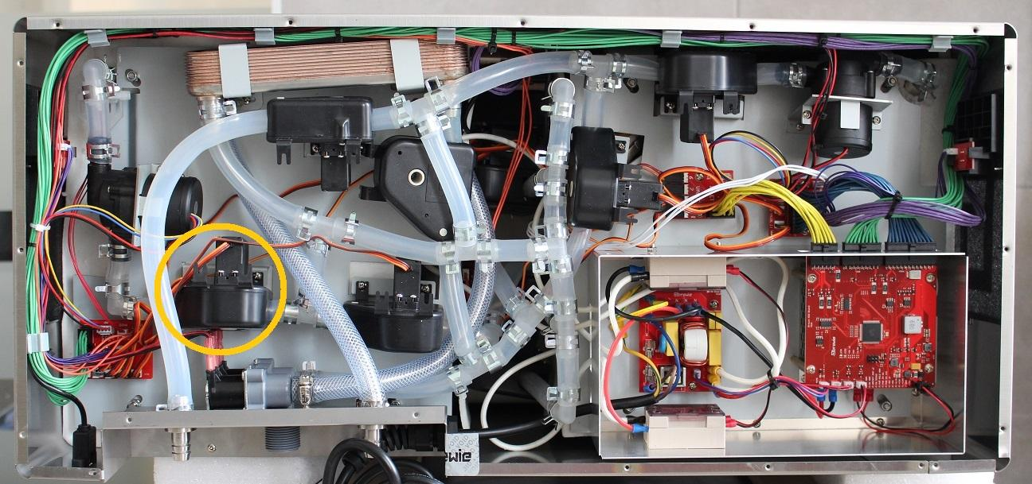

IMPORTANT: First, turn the machine on, enter the Service Interface and open all valves as valves can be removed only in open position.

Pull off the pipe clamp from the encircled fitting and bend back the silicone pipe from the fitting.

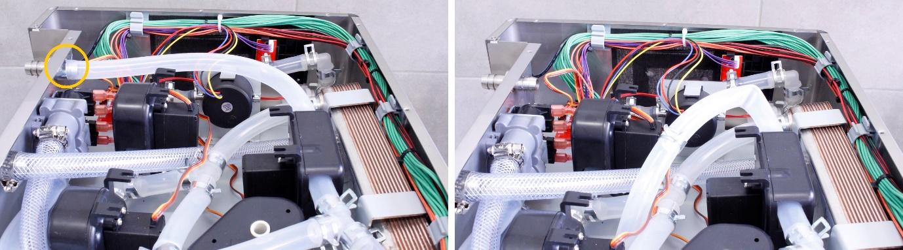

Unscrew the indicated fastening screws of the valve and pull off the hose clamp and the silicone tube from the fitting. Remove the clamp to give way for the valve..

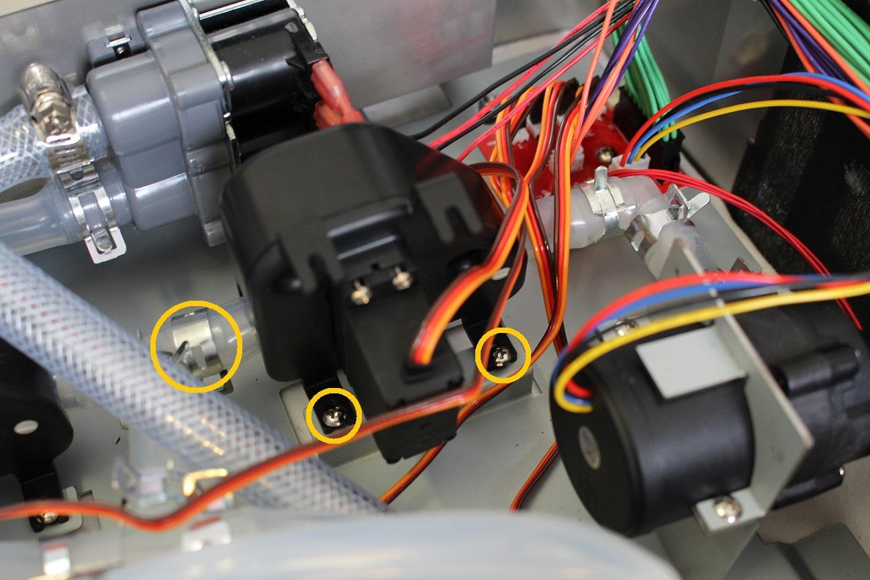

Disconnect the plug of the valve from the PCB panel (Valve No. 2).

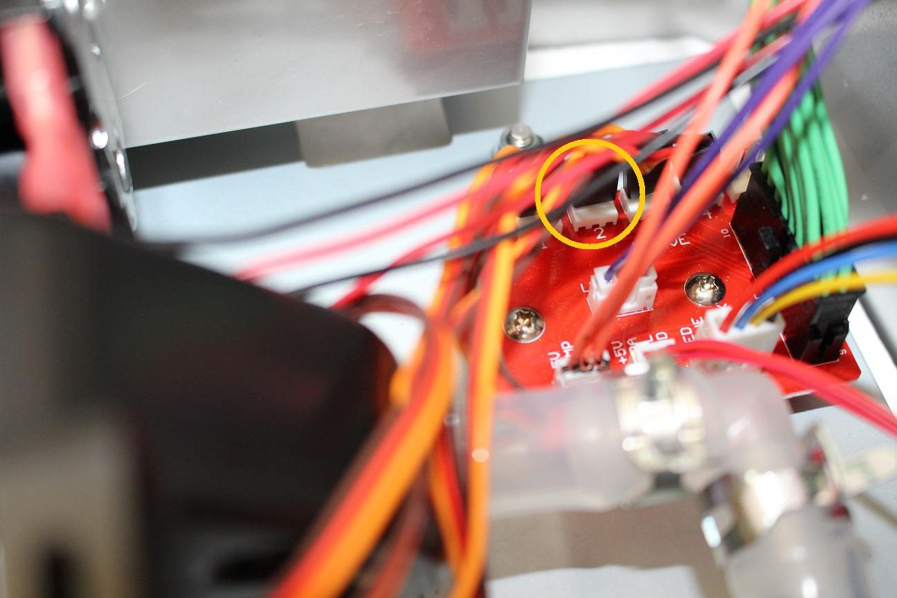

The valve can be removed now.

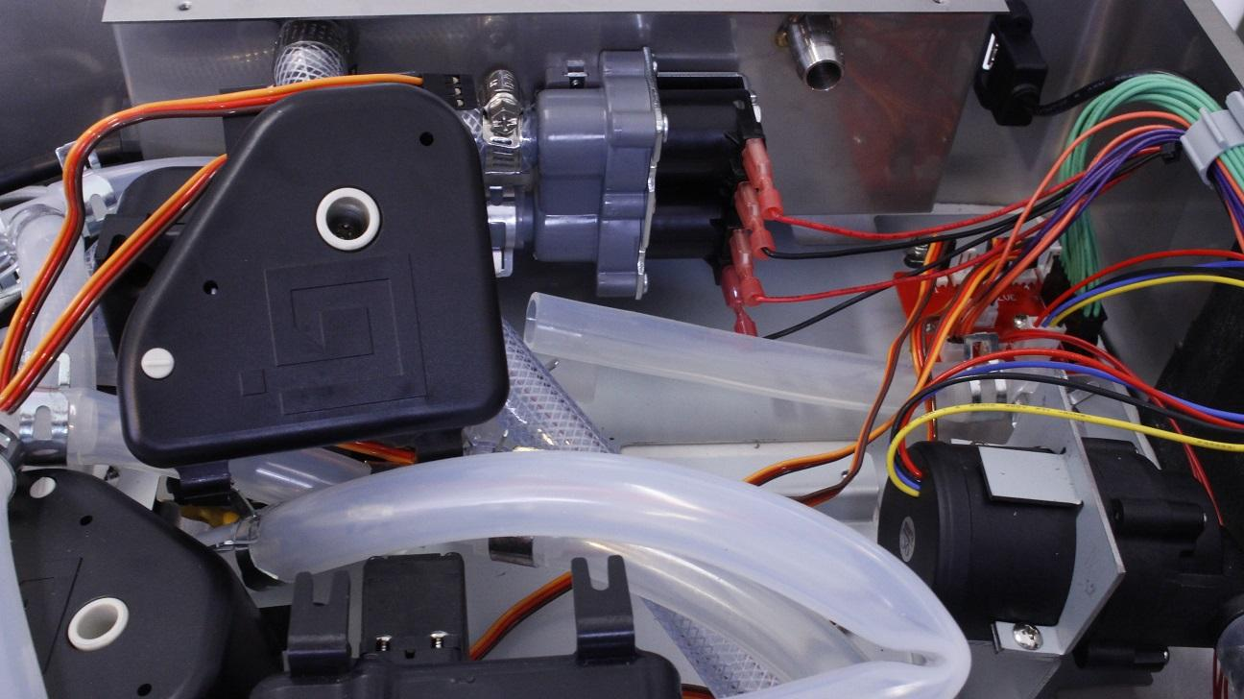

After removal of the valve, check if the inner wall of the silicone tube is clinged together. If it is clinged together, the valve replacement is unnecessary, only the inner walls have to be separated.

Reassemble consists of the same steps in reverse.